**Reading/notes for exam IDATA2304**

**Week: 1 / Topic: History of the internet / Where: Power Point Notes**

**Communication before the Internet**

1. The internet was not invented in an empty space. It was a natural evolution of previous communication technologies: telegraph and telephone
2. Both the post and the internet have a multi-link infrastructure where each link is managed by a specific institution (some institutions may manage many links).
3. The infrastructure is hierarchical – some organizations manage it at the international level, some for each country, some institutions manage a specific city, and so on.
4. The Internet (or the ARPANET) is not the first communication network in the world. It was possible to transmit both voice and data long before the Internet.

**Packet Switching and ARPANET**

Example of Circuit Switching for data transfer:

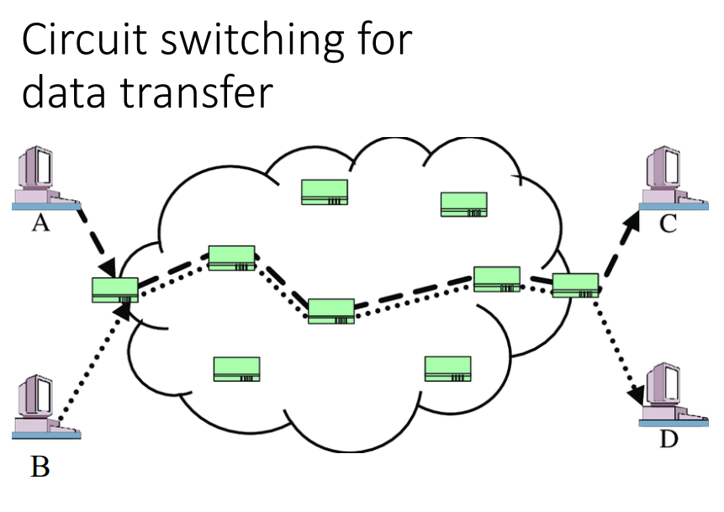

**Circuit Switching Advantages**

* Guaranteed speed
* Guaranteed latency
* Guaranteed quality (limited data loss)

**Circuit Switching Drawbacks**

* Expensive for the users
* Inefficient use of infrastructure

Example of Packet Switching for data transfer:

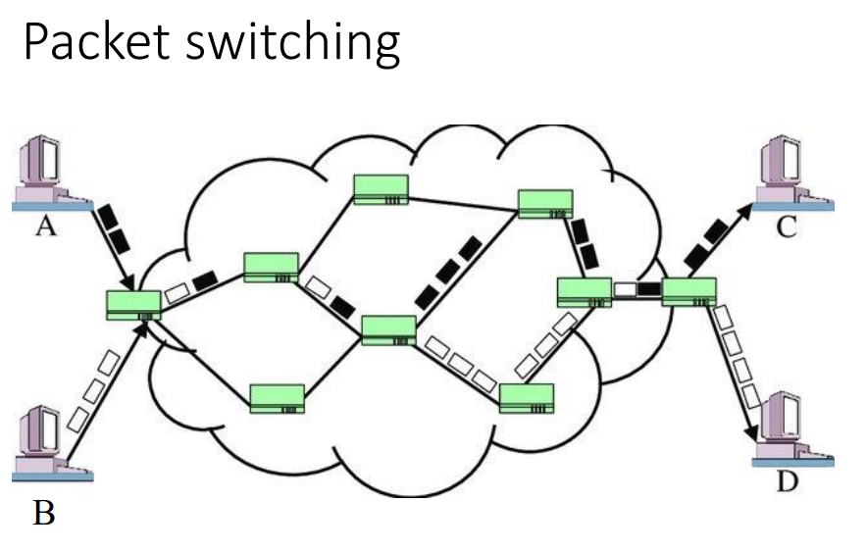

Each device has an address. Each packet contains source and destination address.

**Packet Switching Advantages**

* Cheap
* Efficient use of infrastructure
* Better scalability (can support many users, if they are not very active)

**Packet Switching Drawbacks**

* No guarantees for speed
* Unpredictable latency
* Packet loss can happen (when to many packets wait at a node)

**Packet switching history**

* First packet switching device in 1968: ARPANET

Things to remember

1. Packet switching was introduced for more efficient utilization of infrastructure in computer communication.
2. Packet switching reuses the same communication lines for data exchange between all nodes on the network.
3. First packet-switched network, ARPANET, was created in 1969 in the USA.
4. Norway connected to ARPANET as early as 1973.

**Inter-networking initiative**

1. There were several parallel developments of packet-switched networks.
2. There was a need for common protocol to connect the different proprietary networks together.
3. Development of TCP protocol started in 1974 and a usable version was out in 1983 when ARPANET starting using it.
4. Gradually academic institutions in other countries joined the internet.

**Rapid growth with the web**

1. The web was the main catalyst for the growth of the Internet.
2. The web has four main building blocks: Browser, Web server, HTTP protocol and HTML language.

**Week: 2 / Topic: Fundamental Networking concepts / Where: Book**

**Fundamental Networking concepts – Book notes**

Contains:

* Nuts-and-bolts view (devices)
* Service view
* Protocols
* Data transmission
* Queues, delays, packet loss
* ISPs
* Network backbone
* Access networks

1. **Nuts-and-bolts Description**

* Hosts/End systems
* Communication links
* Packet switches
* Packets
* Routers
* Link-layer switches
* Internet Service Providers (ISPs)
* Protocols
* Transmission Control Protocol (TCP)
* Internet Protocol (IP)

**Host/End systems**

Host is a computer connected via Internet Whereas End system is those of computers connected computer network. Example of end systems are PCs, Web Server, etc. End systems are connected by a network of communication links and packet switches.

**Communication links**

There are many types of communication links, which are made up of different types of physical media, including coaxial cable, copper wire, optical fiber, and radio spectrum. Different links can transmit data at different rates, with the transmission rate of a link measured in bits/second.

**Packet switch**

A packet switch takes a packet arriving on one of its incoming communication links and forwards that packet on one of its outgoing communications-links. Packet switches comes in many shapes and flavors, but the most prominent types in today’s Internet are routers and link-layer switches. Both types of switches forward packets toward their ultimate destination.

**Packet**

In networking, a packet is a small segment of a larger message.

**Routers**

A router is a device that connects two or more packet-switched networks or subnetworks. It serves two primary functions: Managing traffic between these networks by forwarding data packets to their intended IP addresses and allowing multiple devices to use the same Internet connection.

**Link Layer switches**

A network switch is a physical device that operate at the Data Link layer of the Open Systems Interconnection (OSI) model – layer 2. It takes packets sent by devices that are connected to its physical ports and forwards them to the devices the packets are intended to reach.

**ISP (Internet Service Provider)**

An ISP is a company that provides individuals and organizations access to the internet and other related services.

**Protocols**

End systems, packet switches, and other pieces of the internet run protocols that control the sending and receiving of information within the Internet. A network protocol is an established set of rules that determine how data is transmitted between different devices in the same network.

**Transmission Control Protocol (TCP)**

TCP is a standard that defines how to establish and maintain a network conversation by which applications can exchange data. TCP works with the Internet Protocol (IP), which defines how computers send packets of data to each other.

**Internet Protocol (IP)**

IP is the set of rules governing the format of data sent via the internet or local network. IP addresses are the identifier that allows information to be sent between devices on a network: They contain location information and make devices accessible for communication.

1. **Service View**

* Distributed Applications
* Socket Interface

**Distributed Applications**

Distributed Applications involve multiple end systems that exchange data with each other, like Internet messaging, mapping with real-time road-traffic information television streaming.

**Socket Interface**

End systems attached to the Internet provide a socket interface that specifies how a program running on one end system asks the Internet infrastructure to deliver data to a specific destination program running on another end system. This Internet socket interface is a set of rules that the sending program must follow so that the Internet can deliver the data to the destination program.

1. **Protocols**

* Network Protocol
* Def Protocol

**Network Protocol**

A network protocol is like a human protocol, except that the entities exchanging messages and taking actions are hardware or software components of some device. All activity in the Internet that involves two or more communicating remote entities is governed by a protocol.

**Def Protocol**

*A protocol defines the format and the order of messages exchanged between two or more communicating entities, as well as the actions taken on the transmission and/or receipt of a message or other event.*

**4 Access Networks**

Home Access

* DSL
* Cable
* FTTH
* 5G Fixed Wireless

Access in the Enterprise (and the Home)

* Ethernet
* WiFi

Wide-Area Wireless Access

* 3G
* LTE 4G
* 5G

1. **The Network Core**

A Network of Network

* Regional ISP
* Tier-1 ISP
* PoP
* Multi-Home
* Peer
* Internet Exchange Point (IXP)
* Content-provider networks

**6 Delay, Loss and Throughput in Packet-Switched networks**

Queuing Delay and Packet Loss

* Traffic Intensity
* Packet Loss

**Fundamental Networking concepts – Power Point notes**

**Week:** 3 / **Topic:** Physical Layer / **Where:** Power Point Notes

**Week:** 4 / **Topic:** Computer Network Protocols / **Where:** Power Point Notes

**Week:** 5 / **Topic:** Application Layer / **Where:** Power Point Notes

**Week:** 6 / **Topic:** The DNS Protocol / **Where:** Power Point Notes

**Week:** 7 / **Topic:** The Web / **Where:** Power Point Notes

**Week:** 8 / **Topic:** Network programming – TCP sockets / **Where:** Power Point Notes

**Week:** 9 / **Topic:** Transport Layer / **Where:** Power Point Notes

**Week:** 10 / **Topic:** Network Layer / **Where:** Power Point Notes

**Week:** 11 / **Topic:** Retrospective / **Where:** Power Point Notes

**Week:** 12 / **Topic:** Security in computer networks / **Where:** Power Point Notes

**Week:** 13 / **Topic:** Data marshalling / **Where:** Power Point Notes

**Week:** 14 / **Topic:** Some higher-level abstractions / **Where:** Power Point Notes

**Week:** 15 / **Topic:** Wireless network challenges / **Where:** Power Point Notes